1 → arr = [1, 2, 3, 3]

4 → arr[] size n = 4

-----

-------------------

STDIN Funcon Parameters

Sample input 0

Sample Case 0

Each of the next n lines contains an integer, arr[i], where 0 ≤ i < n.

It is guaranteed that a soluon always exists

The rst line contains an integer n, the size of the array arr.

Input from stdin will be processed as follows and passed to the funcon.

Input Format for Custom Tesng

·

·

1 ≤ arr[i] ≤ 2 × 10 , where 0 ≤i< n

4

·

3 ≤ n ≤ 10

5

Constraints

int: an integer represenng the index of the pivot

Returns:

int arr[n]: an array of integers

balancedSum has the following parameter(s):

Complete the funcon balancedSum in the editor below.

Funcon Descripon

·

The index of the pivot is 3.

·

Using zero based indexing, arr[3]=4 is the pivot between the two subarrays.

·

the sum of the rst three elements, 1+2+3=6. The value of the last element is 6.

arr=[1,2,3,4,6]

Example

sums of all elements to the le and to the right are equal. The array may not be reordered.

Q1) Given an array of numbers, nd the index of the smallest array element (the pivot), for which the

WEEK 13

·

The index of the pivot is 1.

·

Using zero based indexing, arr[1]=2 is the pivot between the two subarrays.

·

The rst and last elements are equal to 1.

Explanaon 1

1

Sample Output 1

1

2

1 → arr = [1, 2, 1]

3 → arr[] size n = 3

-----

-------------------

STDIN Funcon Parameters

Sample Input 1

Sample Case 1

·

The index of the pivot is 2.

·

Using zero based indexing, arr[2]=3 is the pivot between the two subarrays.

·

The sum of the rst two elements, 1+2=3. The value of the last element is 3.

Explanaon 0

2

Sample Output 0

3

3

2

1 ≤ numbers[i] ≤ 10

4

1 ≤ n ≤ 10

4

Constraints

int: integer sum of the numbers array

Returns

int numbers[n]: an array of integers

arraySum has the following parameter(s):

Complete the funcon arraySum in the editor below.

Funcon Descripon

The sum is 3 + 13 + 4 + 11 + 9 = 40.

numbers = [3, 13, 4, 11, 9]

Example

Q2) Calculate the sum of an array of integers.

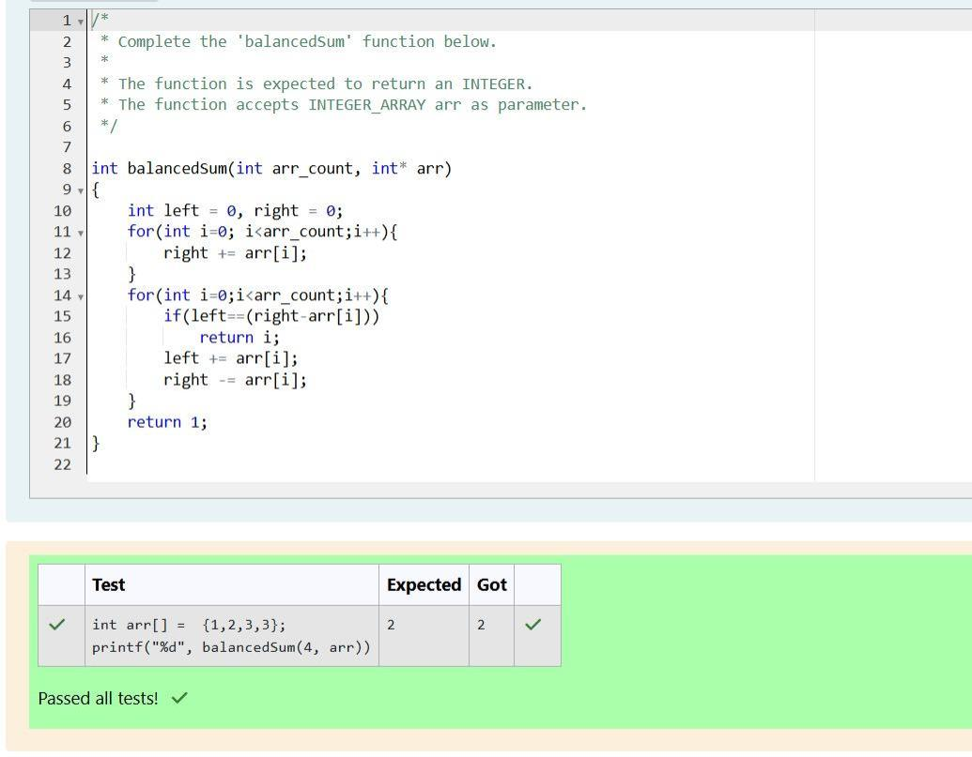

24

Sample Output 1

12

12 → numbers = [12, 12]

2 → numbers[] size n = 2

-----

--------

STDIN

Funcon

Sample Input 1

Sample Case 1

1 + 2 + 3 + 4 + 5 = 15.

Explanaon 0

15

Sample Output 0

5

4

3

2

1 → numbers = [1, 2, 3, 4, 5]

5 → numbers[] size n = 5

-----

--------

STDIN

Funcon

Sample Input 0

Sample Case 0

Each of the next n lines contains an integer numbers[i] where 0 ≤ i < n.

The rst line contains an integer n, the size of the array numbers.

Input from stdin will be processed as follows and passed to the funcon.

Input Format for Custom Tesng

Sample Case 1 Sample Input For Custom Tesng STDIN Funcon ----- -------- 2 → arr[] size n = 2 3 → arr[]

[1, 3, 3, 5, 7], the dierences are minimized. The nal answer is |1 - 3| + |3 - 3| + |3 - 5| + |5 - 7| = 6.

= [5, 1, 3, 7, 3] 1 3 7 3 Sample Output 6 Explanaon n = 5 arr = [5, 1, 3, 7, 3] If arr is rearranged as arr' =

Sample Case 0 Sample Input For Custom Tesng STDIN Funcon ----- -------- 5 → arr[] size n = 5 5 → arr[]

the size of arr. Each of the following n lines contains an integer that describes arr[i] (where 0 ≤ i < n).

arr[i] ≤ 109, where 0 ≤ i < n Input Format For Custom Tesng The rst line of input contains an integer, n,

array Returns: int: the sum of the absolute dierences of adjacent elements Constraints 2 ≤ n ≤105 0 ≤

Complete the funcon minDi in the editor below. minDi has the following parameter: arr: an integer

3| = 1, |3 - 3| = 0, |3 - 4| = 1. The sum of those dierences is 1 + 1 + 0 + 1 = 3. Funcon Descripon

= [1, 3, 3, 2, 4] If the list is rearranged as arr' = [1, 2, 3, 3, 4], the absolute dierences are |1 - 2| = 1, |2 -

adjacent elements is minimized. Then, compute the sum of those absolute dierences. Example n = 5 arr

Q3) Given an array of n integers, rearrange them so that the sum of the absolute dierences of all

12 + 12 = 24.

Explanaon 1

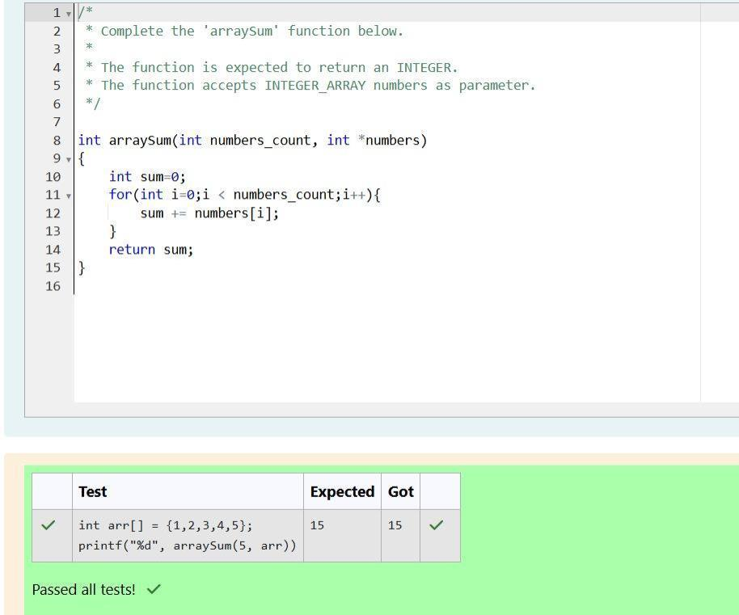

only two elements. The nal answer is |3 - 2| = 1.

= [3, 2] 2 Sample Output 1 Explanaon n = 2 arr = [3, 2] There is no need to rearrange because there are

